Java 9 Feature :→

1) REPL : Read-Eval-Print-Loop,
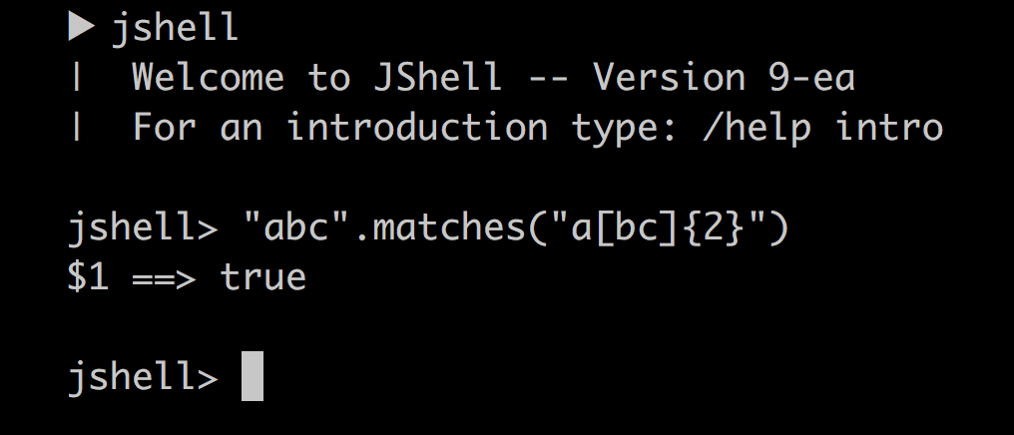

2) 1. The Java Platform module system

module blog {
exports com.pluralsight.blog;

requires cms;
}

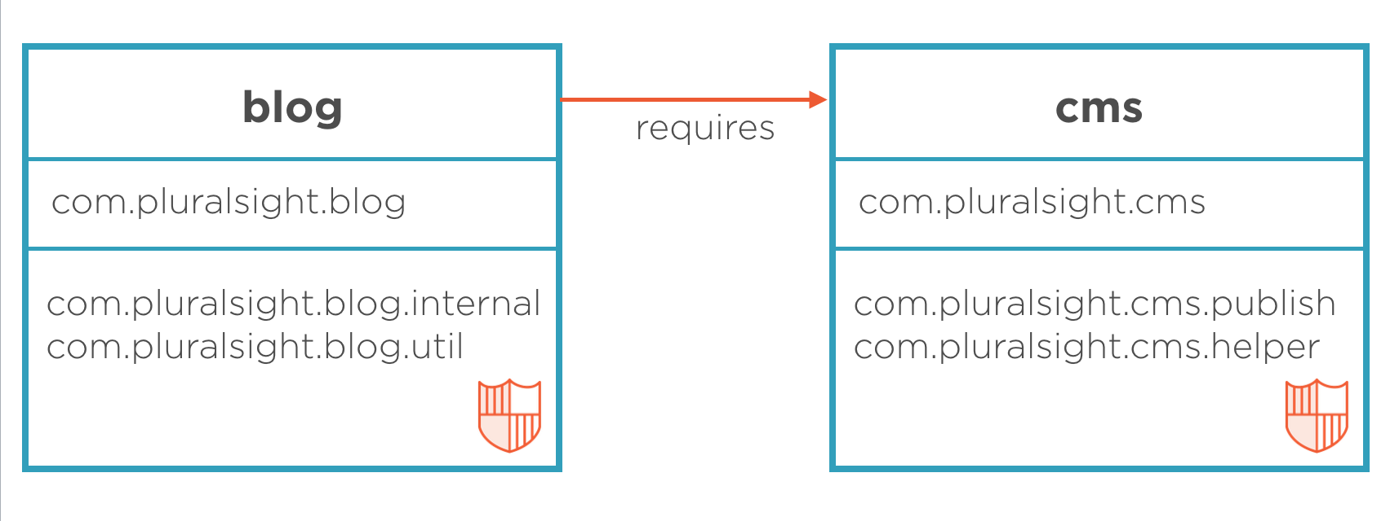

3) Collection factory methods
Often you want to create a collection (e.g., a List or Set) in your code and directly populate it with some elements. That leads to repetitive code where you instantiate the collection, followed by several `add` calls. With Java 9, several so-called collection factory methods have been added:
Set<Integer> ints = Set.of(1, 2, 3);
List<String> strings = List.of("first", "second");

